**Ansible Handlers**

* Handlers: <https://docs.ansible.com/ansible/latest/playbook_guide/playbooks_handlers.html#handlers>
* <https://github.com/asquarezone/AnsibleZone/commit/cdd91cca461760815c87676d5a4c304eb835b904> for the changes with handlers included
* Info.php copying step changed i.e. copied the file to meet desired state so restart executed  
  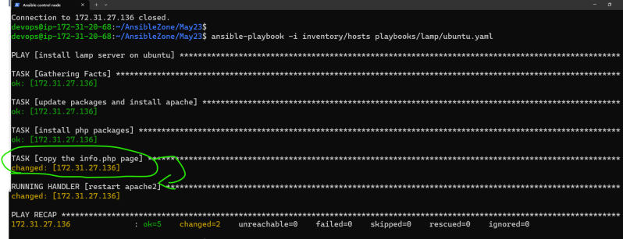
* Info.pyhp copying step was ok i.e. desired state is met so task did nothing, so restart not executed  
  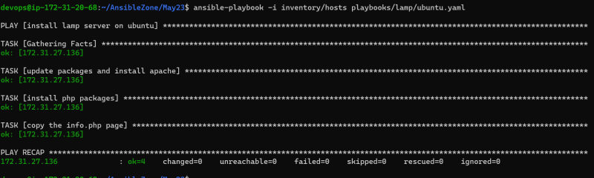

**Inventory**

* Inventory in Ansible represents the hosts which we need to connect to.
* Ansible inventory is broadly classified into two types
  + static inventory: where we mention the list of nodes to connect to in some file
  + dynamic inventory: where we mention some script/plugin which will dynamically find out the nodes to connect to
* As of now lets focus on static inventory
* <https://docs.ansible.com/ansible/latest/inventory_guide/intro_inventory.html#inventory-basics-formats-hosts-and-groups> for official docs on Ansible inventory

In below diagram instead of defining restart multiple time we can define them as handler, and notify handler when it’s needed.

